**QGIS Plugin development**

# Softwares

QGIS 2.14.0 -Essen

Plugin Reloader 0.6.3

Remote Debug 0.4.1

pgAdmin III 1.22.1

Eclipse Neon.3 Release (4.6.3) (for Java) PyDev 5.8.0.... Eclipse plugin

Qt 4.8.3 (

<http://saimei.ftp.acc.umu.se/mirror/qt.io/qtproject/official_releases/qt/4.8/4.8.7/qt-opensource-windows-x86-vs2010-4.8.7.exe>) Qt Designer 4.8.7

Qt Linguist 4.8.7

TortoiseGit 2.4.0.2 (64-bit)

# Setup

## Install QGIS plugins:

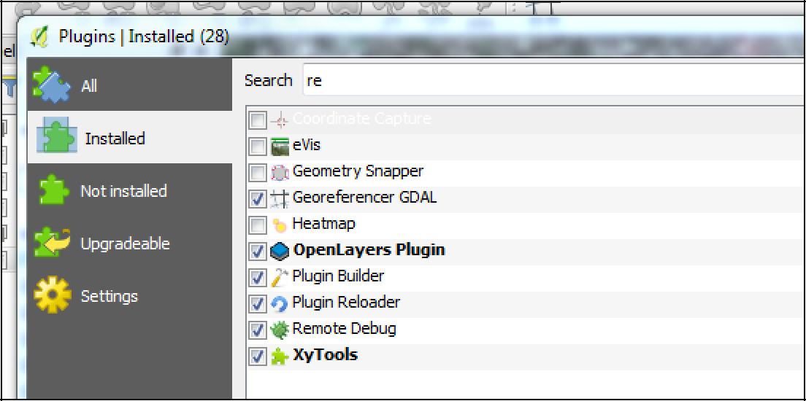

**Connect to local db in pgAdmin III:**

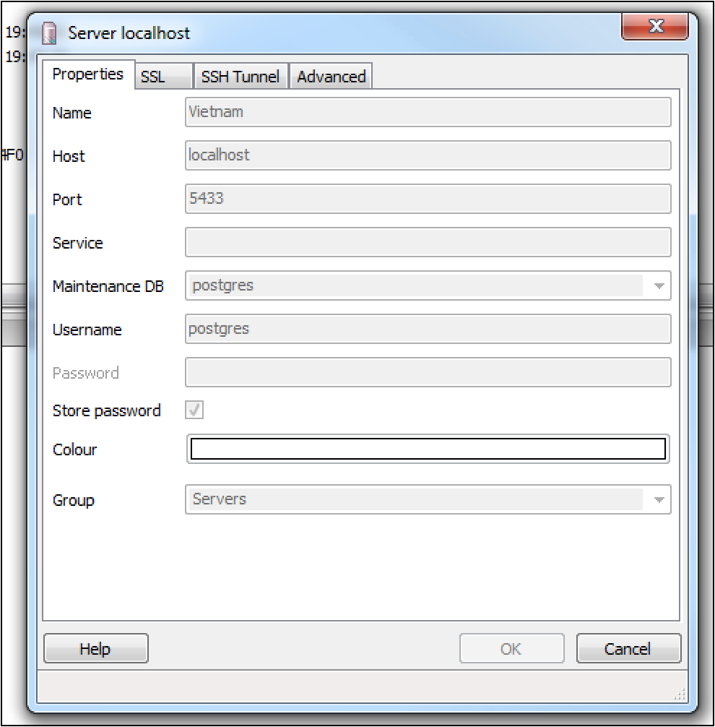

The password if "Friend5"

## Eclipse debugging:

Install PyDev plugin from Eclipse Marketplace Set environmental variables in a bat file:

set PYTHONPATH=C:\Users\adam.ludvig\Projects\Vietnam\FRMS_1.5_test\FRMS-1.5\QGIS\apps\python27\Lib set PYTHONHOME=C:\Users\adam.ludvig\Projects\Vietnam\FRMS_1.5_test\FRMS-1.5\QGIS\apps\python27 call eclipse.exe

Set the python interpreter of PyDev carefully to the same as qgis uses, also add PyQt4 to Libraries and qgis, PyQt4 to Forced Builtins

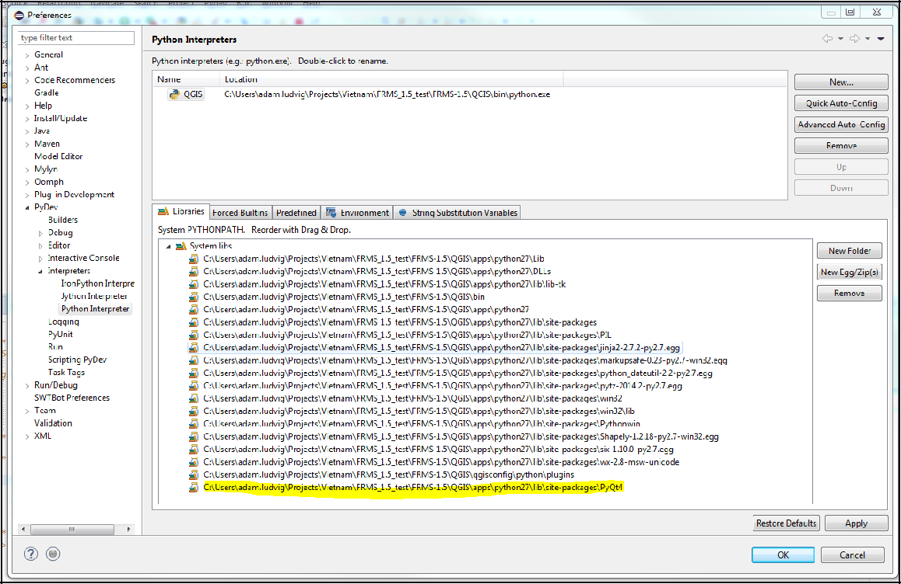

Add the sources to Eclipse as a new General project and specify location

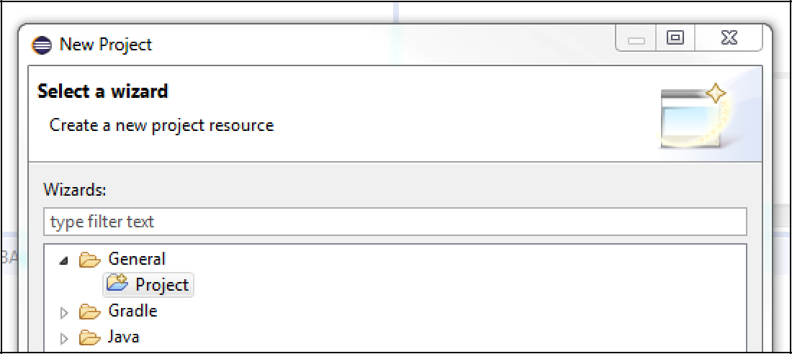

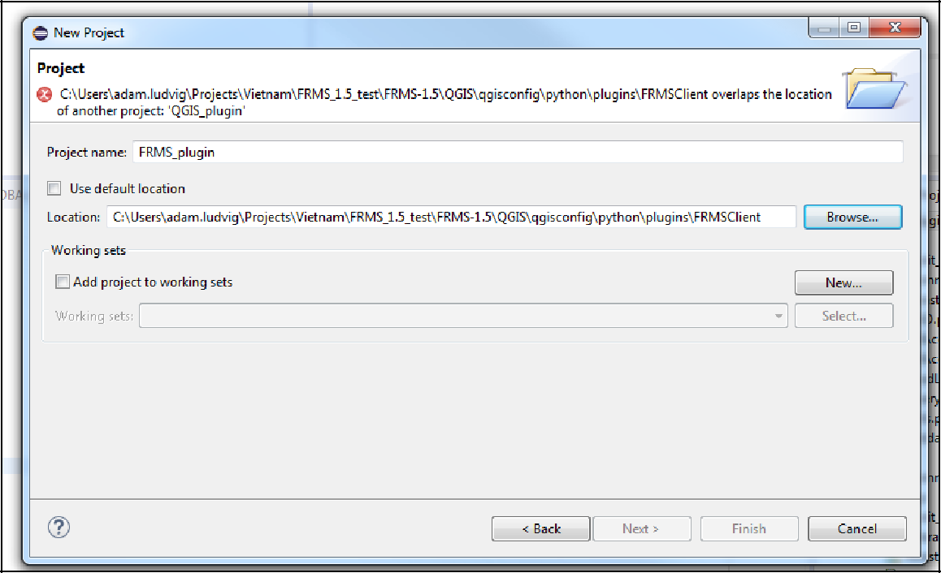

Start debugger in Eclipse by first switching to debug perspective (from Window -> Perspective -> Open perspective) and then starting from PyDev menu

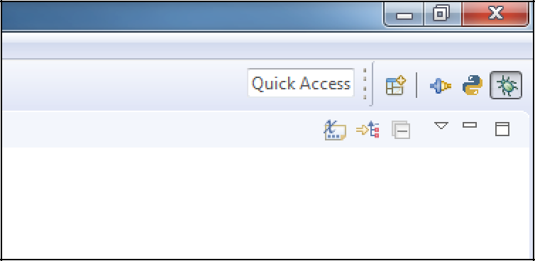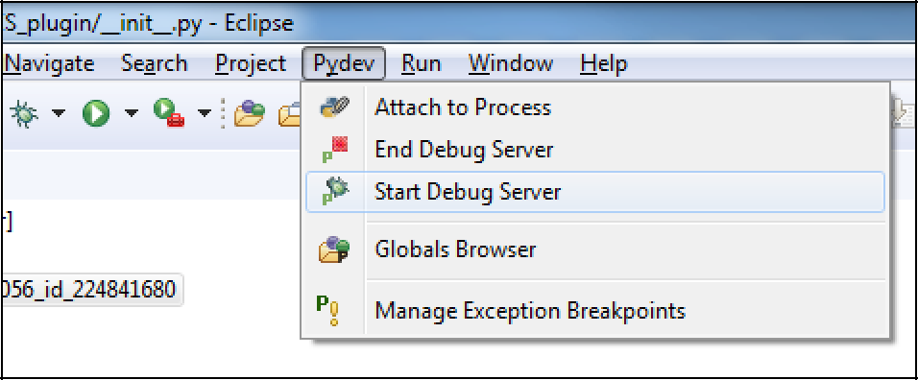

Specify pydevd path in QGIS Remote Debug plugin and connect to eclipse

*;t* Rem ote Deb ugge r

h

Debugger:

[PyDev (Edipse) -. ]

pydevd path: C:1/Jlsers\, dam.ltidv ig\, p2 \pool\plugins\,or g.p ython,pydev _.S.8.0. 201706061859\pysrc

The steps to debug an external program are:

* Go to the debug perspecb ve
* Configure remote debugging of exceptions (PyDev > Manage ExceptionBreakpoints)
* Start the debug server (PyDev > Start Debug Server)
* Press "Connect" to activate remote debugging

The debugger is activated 1tt.'hle1 rn a breakpoint is reactned or an expception is raised (configureable)

PyDev: http :/Jpyde v.org/ Remote debugger

Connect ] [ E_xc_ep_·t_io_n_

Close

l *'r)*